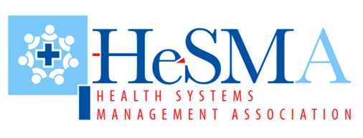
  
  developing the research concept note
  For Masters/PhD Students in Health Systems Management or related academic programs
  Get coached on how to convert your brilliant research idea into a workable research proposal aligned to health systems management pillars and themes.
  - One (1) group session to review basics of academic research proposal writing, first session begins September 29th, 2018 at 1pm.
  - Three (3) one-on-one coaching sessions on developing the concept note
  One-on-one sessions scheduled on Saturday afternoons,
  1:00pm – 3:00pm OR 4:00pm – 6:00pm. Skype & Face-to-face options available.
  Influencing Health through Systems Approach
  Align YOUR RESEARCH IDEA TO HEALTH SYSTEMS THINKING
  quarterly group sessions on PROPOSAL WRITING FOR ACADEMIC RESEARCH
  4 sessions
  earn
  100 cpd points
  kes 16,500 investment
  book your session
  hesma
  Email: info@hesma.or.ke
  Tel: 020 2330034 WhatsApp/call 0729872543
  Facilitators
  - Experts & Founders
  - Health Systems Specialist

